SLALOMANIA
TASK CATALOGUE
Aspres sur Buech - from September 14th to 18th, 2011
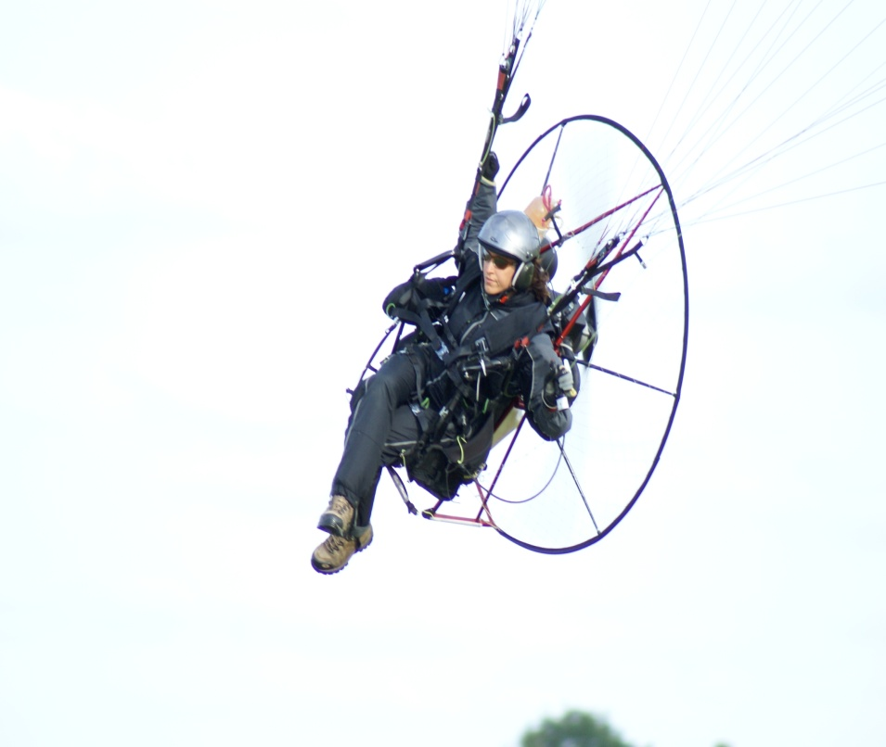
NB. A pilot may be male or female but for the sake of convenience, this document refers to the pilot as he.

TASK : FIGURE EIGHT CLASSES : PF1-PL1 –PF1E
INDIVIDUAL / TEAM TURNS : 4 (D-G-D-G)
DESCRIPTION : The pilot takes-off at the Marshal’s signal. On the green flag (or any other signal determined by the Competition Director), the pilot enters the course through the entry/exit gate in the direction of the arrow and timing commences at this point. The pilot flies toward the pylon facing him, goes round it clockwise and back to the centre through the « red/blue » gates as indicated in the diagram below. He continues towards the second pylon and goes round it anti-clockwise and returns to the centre through the entry/exit gate. The circuit must be run twice (each pylon must be gone round twice) and timing will cease at the third passage through the « red » entry/exit gates.

1-3
2-4
35 to 50 M
35 to 50 M
Start and end of timing
Entry and exit gate
EXIT

Penalties: for every gate missed (entry, exit and intermediary), a maximum score will be given which will be increased by 5 points.
Each error in direction will give the maximum score increased by 5 points.

TASK : TRIANGLE CLASSES : PF1 –PF1E
INDIVIDUAL / TEAM TURNS : 4 (G-D-G-D)

DESCRIPTION : The pilot takes-off at the Marshal’s signal. On the green flag (or any other signal determined by the Competition Director), the pilot enters the course through the entry/exit gate in the direction of the arrow and timing commences at this point. The pilots flies towards the pylon A, facing him, and goes round it anti-clockwise, he then flies to pylon B, which he goes round clockwise, as indicated in the diagram. He continues to the third pylon C which he goes round clockwise, he then flies back to pylon A which he goes round clockwise and finally flies to the exit gate. Timing will stop on the second pass of the pilot through the red entry/exit gate.

50 to 60 M
50 to 60M
Start and end of timing
Entry and exit gate
EXIT
1 G - 4 D
75 to 80 M
2 D
3 G
B
C
A

Penalties : An entry/exit gate missed will lead to a maximum score increased by 5 points.

TASK : Y CLASSES : PF1 –PL 1 -PF1E
INDIVIDUAL / TEAM TURNS : 4 (D-G-D-G)

DESCRIPTION : The pilot takes-off at the Marshal’s signal. On the green flag (or any other signal determined by the Competition Director), the pilot enters the course through the entry/exit gate in the direction of the arrow and timing commences at this point. The pilot flies towards pylon A on his right, goes round it clockwise and flies to pylon B which he goes round anti-clockwise, as indicated in the diagram. He then flies to pylon C which he goes round clockwise and on to pylon D which he goes round anti-clockwise and then goes through the « red » entry/exit gate. Timing will stop on the second pass of the pilot through the red entry/exit gate.

35to 50M
Start and end of timing
Entry and exit gate
EXIT
4 G
70 to 100 M
1 D
2G
A
3 D
35to 50M
B
C
D

Penalties : An entry/exit gate missed will lead to a maximum score increased by 5 points.

TASK: RETURN SLALOM CLASSES : PF1 –PL 1 -PF1E
INDIVIDUAL / TEAM

DESCRIPTION : The pilot takes-off at the Marshal’s signal. On the green flag (or any other signal determined by the Competition Director), the pilot enters the course through the entry/exit gate in the direction of the arrow and timing commences at this point. The pilot flies towards the pylon facing him, pylon A, and goes round it clockwise, he then flies back to the starting point. Timing will stop on the second pass of the pilot through the entry/exit gate.
On the run he must go round two stakes, the first to the right and the second to the left, as indicated in the diagram.
In the case where two slalom courses are used, slalom B will be reversed as per the diagram.

Entry Exit Exit Entry

A
B
70 à 100 M

Penalties : An missed entry or exit gate will lead to a maximum score increased by 5 points.

NOTE : On a single run, the pilot may choose the direction in which he goes round the pylon. In the case of a match or race using parallel slalom courses, the direction in which the turn must be taken will be decided by a draw. The same will apply for the team event. Entry and Exit Gates may either be together or separate, depending the choice of the task : individual or team

