« SLALOMANIA »
PARAMOTOR WORLD CUP

2011 SLALOM WORLD CUP

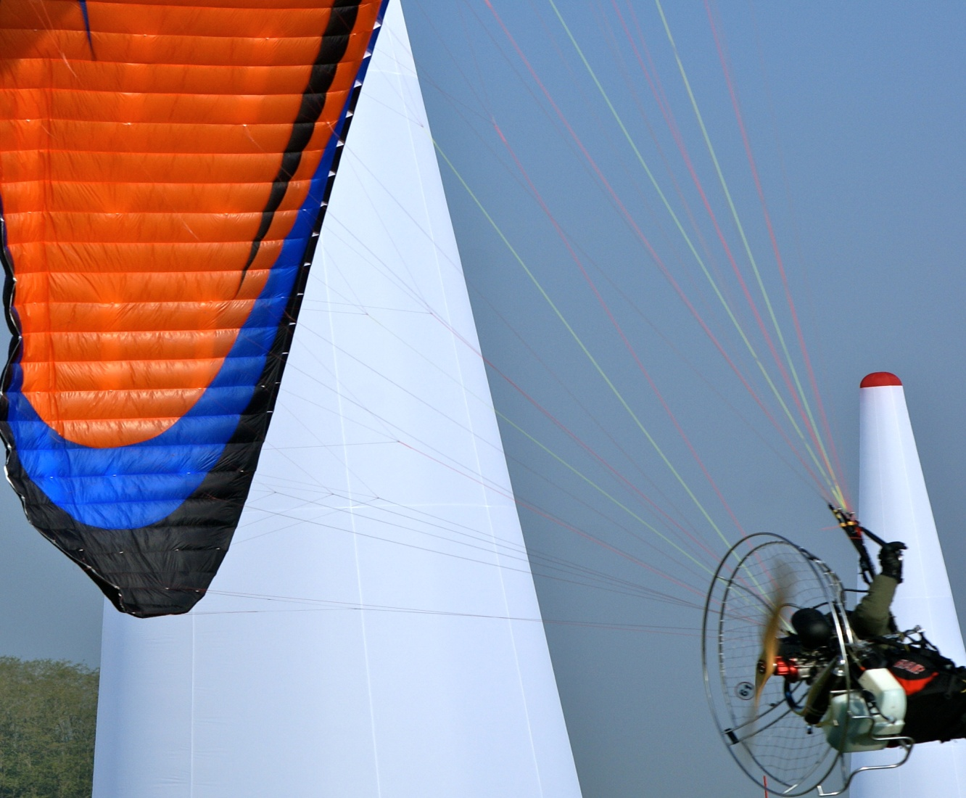

ASPRES SUR BUECH AIRFIELD/HAUTES ALPES
Dates : from September 14th to 18th 2011

- General
    - This document and the annexed Task Catalogue comprise the rules for the Paramotor World Cup « Slalomania ». The final version will be available in July 2011 on the following web site: www.ffplum.com.

  - Introduction
    - The aims of the World Cup are:
To determine the winner of the competition.
To promote the discipline “manoeuvrability” within the Paramotor community
To test the event prior to it’s introduction as a World Championship.
To share knowledge and experience and the different techniques used by the pilots from different countries.
    - The competition is open to all pilots from any country on the condition that they hold a current FAI Sporting Licence.
    - Each registered pilot accepts the present rules and declares to respect them and to accept any consequences that may result in his/her participation.
  - Dates and Venue: from September 14th to 18th 2011 (training possible from September 12th). Aspres sur Buech Airfield in the Hautes-Alpes, France.

  - Entry Fee: 250 euros paid before June 15th 2011
300 euros from June 15th 2011

  - Events and Ranking
    - The events of the World Cup are slalom events.
    - The events are open to the solo foot-launched and landplane (trike) Paramotor classes PF1-PL1-PF1E.

Warning: The solo foot launched electric engine Paramotor will be ranked separately on the condition that there are least 6 people registered from three different countries. In the case that six countries are represented, this class will count in the ranking by country.

    - For the foot-launched class, the World Cup will include an individual mixed ranking, a team ranking and a ranking by country.
For the trike class, only the individual events will be ranked.
    - Each team will include three pilots in each class. Each country can register more than one team and individuals.
    - The ranking will be calculated by adding the placing achieved in each event, squared.
    - The individual events comprise a slalom that is scored by the time taken to complete the course and/or for parallel slaloms, by placing.
    - Team events comprise a relay that is scored by the time taken to complete the course and/or for parallel relays, by placing.
    - The winner of the World Cup or the winning team will be whoever achieves the smallest number of points.
    - The winning country will be calculated by adding the points achieved by the best team of any country added to those of the top three individuals from that country.
    - Tie-break: in the case of a tie, the Competition Director will hold a tie break round of the task of his choice. At the General Briefing, the Competition Director will announce which task will serve to break any tie should there be insufficient time to hold a tie breaking round,
    - The competition will be valid if a minimum number of three tasks are completed.

  - Programme
    - The « Slalomania » World Cup events will be held at the airfield in Aspres sur Buech (Hautes Alpes) and will start on the morning of Thursday September 15th and will finish on Saturday September 18th at 6pm.

    - Each event will include a number of rounds to be decided by the Competition Director and depending on the weather conditions.

    - Timetable:
Wednesday 14th
2pm to 6pm Registration and Control of Paperwork
7pm General Briefing
Thursday 15th to Friday 17th
17 qualifying rounds (time to be determined by the Competition Director)
Saturday 18th
9am to 6pm Final Rounds
7pm Prize Giving
8:30pm Closing Dinner (buffet)

  - Prize Giving
    - Medals will be given to the top three places in each category.
    - A trophy will be given to the best Country
    - The winners or winning teams will be given a cash prize :
Solo Foot-Launching: 500 euros
Solo Trike : 500 euros
Team : 1000 euros

- COMPETITION RULES

  - Foot-launched and Trike Paramotors
    - All Paramotors registered in the competition must comply with Section 10 of the FAI Sporting Code and the French regulations. Foreign pilots must also obtain the right to fly over French territory from the Organiser.
    - The list of FAI classes is as follows:
PF1: Paraglider control / Foot-launched / Flown solo / Thermal engine – PL1: Paraglider control / Landplane / Flown solo / Thermal engine and PF1E: Paraglider control / Foot-launched / Flown solo / Electric engine
    - Take-off will be without any assistance other than from a team member and only after permission by the Competition Director.
    - Depending on the type of task and the aerological conditions, equipment may be changed under the following conditions and only after receiving the approval of the Competition Director:

- One engine change during the whole competition
- Canopies: no restriction
    - Each pilot is responsible for his own equipment. The Competition Director may ground equipment if, in his view, it is not in conformity or is dangerous.

  - Registration
    - Registration is possible from May 1st, 2011 by Internet: www.ffplum.com. Registration may be completed on site at Aspres on Tuesday September 14th. Payment may be made by bank transfer or by PayPal.
    - Pilots must be 16 years old on the first day of the competition.
    - Each pilot must present original copies of flight documents issued by the authorities of their country.
    - Each pilot must hold valid third party insurance of at least 750 000 SDR. It is possible to take out the required insurance at the competition site (see offer on the Competition Web site)

  - Complaints
    - Any complaint must be handed to the Competition Director or his assistant by the Team Leader, as soon as possible after the reason for the complaint is known. A Complaint form will be made available for Team Leader use.
    - In the case the response of the Competition Director is considered unsatisfactory, a protest may be lodged with the three-person Jury together with a protest fee of 25€ within one hour after the response has been given. The 25€ will be refunded if the Protest is upheld by the Jury or if the Protest is withdrawn.

- Flight Safety

  - Briefings
    - Before the start of the Competition, the Competition Director will give a general briefing covering the specifics of the Aspres sur Buech airfield, information about slalom flying and the circuits to be used for entry to and exit from the course, as well as general information of interest to the pilots.
    - Flights outside of the airfield are forbidden for the duration of the competition unless the Competition Director gives express permission.
    - All the pilots must attend the briefings and not cause any disturbance.
    - A daily briefing for Team Leaders will be held during the Competition.
  - Mandatory Equipment
    - All pilots must wear a helmet. The non-respect of this rule will cause immediate disqualification with the loss for the team of all points acquired.
    - A reserve parachute must be carried. The non-respect of this rule will cause immediate disqualification with the loss for the team of all points acquired.
    - Leg, arm and back protection are highly recommended.

  - Other Equipment
    - With the exception of any equipment considered dangerous by the Competition Director, all other equipment is authorised.

  - Task Preparation
    - If the weather conditions and time permit, the Competition Director may allow time for training prior to each new task or series of tasks.
    - Each pilot or each team will take-off, land, fly and run the course under their own responsibility and accept the risks inherent to flying slalom.
    - Each pilot or each team accept to fly within his, her or their own physical limits and within the flight limitations of their equipment. `

  - Discipline au sol
    - During the briefings, all signals used by the Marshals, permission to take-off and landing procedures will be indicated. Their non-respect will result in penalties being applied.

  - Flight Limitations
    - Any manoeuvre considered as dangerous for the general public, buildings and competition set-up, another aircraft or the pilot himself are forbidden and will result in a penalty or disqualification.
    - It is forbidden to fly over housing.
    - It is strictly forbidden to fly in cloud.
    - Every pilot must take care to avoid any risk of collision.
    - During all events, it is forbidden to fly over the Slalom course with the exception of media related flights.

- Competition Tasks

  - General
    - All information necessary for competitors will be posted either on a Notice Board or on the Competition Web site. It is the responsibility of each pilot to ensure that they are in possession of all relevant information and cannot pretend otherwise.
    - Once a pilot has taken-off, they have accepted that the conditions for the Task are acceptable. Rain or unstable conditions are not a reason for complaint or protest. A task may be rerun at the discretion of the Competition Director if he considers that a competitor was unfairly penalised.

  - Tasks
    - A task catalogue for individual, team and trikes will be available to the Competition Director.
    - Each task may be the object of several rounds (i.e. the figure eight task could be for two rounds). Some tasks will be timed; others will be ranked after a match (i.e. the triangle task two rounds, outwards and return). Details are available in the task catalogue.
    - If it is necessary, the Competition Director may adapt a task by modifying it. Any modification must have the approval of the Jury.
    - Some tasks require specific conditions as defined in the catalogue.
    - Tasks will be controlled either by electronic or manual timing.
  - Slalom Equipment: inflatable pylons of 12, 8 or 6 metres (at the Competition Director’s discretion) articulated stakes, cones, timing sensors.
  - Event Interruption
    - The Competition Director may decide to interrupt an event or to start it again depending on the conditions. He may also cancel a round, several rounds or the whole of an event.

- PENALTIES
  - General
    - Any infringement to flight safety, safety rules or task rules will lead to a penalty of 15 points or disqualification.
    - Disqualification terms:
      - Unauthorised flights during the competition.
      - Use of unauthorised equipment or equipment not in conformity.
      - False declaration
      - Repeated infringements of Competition Director instructions
      - Repeated disturbance during Briefing
      - The use of illegal substances in contradiction with the anti-doping rules.
      - Medical reasons (unfitness, neglect of treatment,.)
  - Specific (see Task Catalogue)

- TEAM TASKS (3 pilots):
  - Général
    - All tasks can been done as a team:
    - The entry and exit gates are set for each task at the discretion of the Competition Director.
    - The three pilots take-off at the same time, the first enters the run, the two others wait for their turn to enter the circuit in a relay format. The second pilot enters the entry gate once the first pilot has passed through the exit gate. The same applies for the third pilot who enters the course once the second pilot has passed through the exit gate. If this does not happen, a penalty will be applied.
  - Team Penalties:
    - First early entry before the relay: 5 seconds; second: 15 seconds.
    - Any mistake in the course (miss a gate, wrong direction, miss a pylon) will cause the elimination of the team for that round: the score will be that of the lowest placed team increased by 5 points.
  - Note: The team score is not the sum of the individual scores (time or placing) but the result of the overall performance of the relay by the team in the task selected by the Course Director.

- SCORING
  - The Competition Director will decide whether to score a task (team or individual) by timing or by match racing.
  - Timing: the performance will be timed precisely, the resulting time may, if relevant, have penalties added: i.e. the 1st place will count for one point.
  - Match / Racing: in the form of a match table either a direct match or the best of three rounds. Each pilot or team eliminated will retain their time, which will determine their ranking. The four last remaining pilots or teams will be ranked following a final match or best of three rounds.
  - Decisions and recourse: The decisions by the Competition Director cannot be subject to complaint. In case of a problem, a pilot can, however, follow the procedure described in 2.3. of these rules.

1/4 FINAL | ½ FINAL | 3rd & 4th Place | Semi FINAL | FINAL | WINNER
PILOT A
 | PILOT A |  | PILOT A
PILOT B
 |  |  |  | PILOT D
PILOT C
 | PILOT D
PILOT D
 |  | PILOT F |  |  | PILOT D
PILOT E
 | PILOT F
PILOT F
 |  |  |  | PILOT H
PILOT G
 | PILOT H |  | PILOT F
PILOT H

In this example: B (67s) C (72s) E (no time) G (65s)
1st: D
2nd H
3rd F
4th A
5th G temps65 s
6th B temps 67 s
7th C temps 72 s
8th E no time: eliminated

