LOCAL REGULATIONS

FOR THE 17thFAI WORLD MICROLIGHT CHAMPIONSHIPS
Hosín Airfield, Czech Republic, 23 rd – 30 th July 2022
Light Aircraft Association of Czech Republic
ON BEHALF OF THE FÉDÉRATION AÉRONAUTIQUE INTERNATIONALE
Organizer Address: LAA ČR, Ke Kablu 289, 102 00 Praha 10
Tel: +420 608 465 399
E-mail info@wmc2022.net
Official Web Site www.wmc2022.net
Facebook/HosinWMC2022

AUTHORITY
These Local Regulations combine the General Section and Section 10 of the FAI Sporting Code with regulations and requirements specific to this championship. The FAI Sporting Code shall take precedence over the Local Regulation wording if there is omission or ambiguity.

CLARIFICATION
Classes AL1, AL2, GL1, GL2, WL1 and WL2 are "Microlights"

CONTENTS
AUTHORITY 1
CLARIFICATION 1
CONTENTS 1
1.1 GENERAL 3
1.2 PROGRAMME DATES 3
1.3 OFFICIALS 3
1.4 ENTRY 3
1.5 REFUND OF ENTRY FEES 4
1.5.1 EVENT CANCELLATION 4
1.5.2 WITHDRAWAL FROM A CAT1 EVENT 4
1.6 INSURANCE 4
1.7 LANGUAGE 4
1.8 MEDALS AND PRIZES 4
1.9 CHAMPIONSHIP CLASSES 4
1.10 GENERAL COMPETITION RULES 5
1.11 FLYING AND SAFETY REGULATIONS 6
1.12 CHAMPIONSHIP TASKS 8
1.13 CONTROL OF TASK FLIGHTS. 10
1.14 GNSS FLIGHT RECORDERS 11
1.15 SCORING 12
2.1 GENERAL REMARKS 14
2.2 FLIGHT CONTROL 14
2.3 SCORING 14
2.4 GENERIC TASKS 15
Czech Republic Airspace Informations 18
Airport Hosin (LKHS) 18
1st Interntaional Microlight flying navigation camp 19
Petr Tucek Navigation Cup 2022 20

1 General

GENERAL
The purpose of the championships is to provide good and satisfying contest to determine the champion in each class and to reinforce friendship amongst pilots and nations (S10 4.2).

1.2 PROGRAMME DATES
Training, aircraft inspection, registration: 20 th – 22 nd July 2022
Opening Ceremony: 23 rd July 2022
First Competition briefing: 23 rd July 2022
Contest Flying Days 24 th – 29 th July 2022
Closing Ceremony, Prize-giving 30 th July 2022

1.3 OFFICIALS
Director Jiří Nečas
Deputy Director Petr Jonáš
International Jury : President Rob Hughes (UK), Kristian Dolhai (HUN), Wolfgang Lintl (GER)
Stewards : Michael Kania (GER)

1.4 ENTRY
The Championships are open to all Active Member and Associate Member countries of FAI who may enter:
For Microlight championship 6 pilots plus one all-female crew in each class. Entries must be made on the official Entry Form. If applications, with fees paid, are not received by 23 rd July 2022, the entry may be refused.

The entry fee before 30 th May 2022 is:
400 EUR for pilot in each class except
400 EUR for each co-pilot or navigator
80 EUR for each Team Leaders and accompanying persons.
50 EUR Other (if any).

The entry fee after 30 th May 2022 is:
500 EUR for pilot in each class except
500 EUR for each co-pilot or navigator
100 EUR for each Team Leaders and accompanying persons.
50 EUR Other (if any).

The entry fee includes:
- Competition operations (setting, controlling and evaluating the tasks)
- All competition materials (maps, task descriptions, control point atlases, etc.)
- Free use of the airport and free entry to all official events.
- Camping place for each team with water, electricity and wireless internet
- Aeronautical VFR charts and Aerodrome Database
- Preferential prices to eat

The entry fee is to be transferred before 16th July 2022 to account number:
2701042472/2010
IBAN: CZ3920100000002701042472
BIC/SWIFT: FIOBCZPPXXX
FIO Banka

1.5 REFUND OF ENTRY FEES

1.5.1 EVENT CANCELLATION
If a CAT 1 event is cancelled or does not take place, all entry fees that have been paid shall be returned in full and no CIMA sanction fees are due.
If a CAT 1 event is stopped by Jury decision or by force majeure, a portion of the entry fees, to be determined by the CIMA bureau, shall be returned. In this instance, CIMA sanction fees shall be paid in full.

1.5.2 WITHDRAWAL FROM A CAT1 EVENT
Participants who withdraw from a CAT1 championship before the start of the official practice period shall be entitled to a refund of part of their entry fees according to the scale below. In this instance, no CIMA sanction fees are due.
30 days (or more) before = 100%
29 days (or less) before = 50%
Participants who withdraw after the start of the official practice period shall receive no refund and CIMA sanction fees shall be paid in full.

1.6 INSURANCE
Third party insurance of minimum 750 000 SDR is obligatory. Personal accident insurance for team members and insurance against damage to aircraft are highly recommended. Documentary proof of insurance as specified on the Entry Form must be presented to the Organizers at Registration. (GS. 3.9.6)

1.7 LANGUAGE
The official language of the Championships is English.

1.8 MEDALS AND PRIZES
FAI medals will be awarded to:
- Pilots placed first, second and third in each class (including PF1f if in compliance with S10 4.3.2).
- National teams placed first, second and third.
- FAI Diplomas will be awarded for those placed first to tenth.

1.9 CHAMPIONSHIP CLASSES
The Championships may be held in the following classes (S10 1.5):
WL1, WL2, AL1, AL2, GL1, GL2
Each class is a championship in its own right and as far as possible interference of one class by another shall be avoided.

1.9.1 CLASS VIABILITY
For a championship to be valid there must be competitors from no less than 4 countries in a class, ready to fly the first task, and must start a minimum of one task. (S10 4.3.2)

1.9.2 CHAMPIONSHIP VALIDITY
The title of Champion in any class shall be awarded only if there have been at least 6 separate tasks.

1.10 GENERAL COMPETITION RULES

1.10.1 REGISTRATION
On arrival the team leader and members shall report to the Registration Office to have their documents checked and to receive supplementary regulations and information. The following documents are required:
- Pilot License and qualifications.
- Evidence of competitor's identity.
- Valid FAI Sporting License for pilot and navigator.
- Aircraft Certificate of Airworthiness or Permit to Fly.
- Minimum speed declaration
- Evidence of conformity to class rules.
- Certificate of Insurance.
The Registration Office will be open as indicated on the information board.
Registration forms may be inspected by Team Leaders on request prior to the start of competition flying.

1.10.2 PILOT AND NAVIGATOR QUALIFICATIONS
A competing pilot shall be of sufficient standard to meet the demands of an international competition and hold a valid pilot license or equivalent certificate. Both pilot and navigator must hold an FAI Sporting License issued by his own NAC. The navigator must have reached the age of 14 years.

1.10.3 AIRCRAFT AND ASSOCIATED EQUIPMENT
Aircraft and equipment provided by the competitor must be of a performance and standard suitable for the event.
Each aircraft must possess a valid Certificate of Airworthiness or Permit to Fly not excluding competition flying. This document must be issued in or accepted by the country of origin of the aircraft or the country entering it or the country of the organisers. The aircraft must comply with the FAI definition of a Microlight (S10 1.3).
The aircraft shall fly throughout the championships as a single structural entity using the same set of components as used on the first day except that propellers may be changed provided that the weight limit is not exceeded and the Certificate of Airworthiness or Permit to Fly is not invalidated. (S10 4.17.4)
All aircraft must be made available during the Registration period for an acceptance check in the configuration in which they will be flown. The organisers have the right to inspect for class conformity and airworthiness and, if necessary, ground any aircraft for safety reasons at any time during the event.
All aircraft must be equipped with a simple method of sealing the fuel tank.
All aircraft must be equipped with a simple method of sealing the radio, or radio must be unistall.

1.10.4 TEAM LEADER RESPONSIBILITIES
The team leader is the liaison between the organisers and his team. He is responsible for the proper conduct of his team members, for ensuring that they do not fly if ill or suffering from any disability which might endanger the safety of others and that they have read and understand the rules.

1.10.5 STATUS OF RULES AND REGULATIONS
Once competition flying on the first day has started:
- No rules or regulations may be changed. Any additional requirements within the rules needed during the event will not be retrospective. (S10 4.9.4).
- Competitors may not be substituted, change to another class nor change their aircraft.

1.10.6 PRACTICE & REST DAYS
An official practice period of not less than 2 and not more than 5 days immediately preceding the opening of the Championships shall be made available to all competitors. All the infrastructure for the competition (camping, maps, offices, scoring...) shall be ready for the first day of the official practice period. If practicable, on at least one practice day a task should be flown under competition conditions to test the integrity of the organisation. The scores thus generated shall not be counted. (S10 4.7.3)
Rest days will only be held on account of bad weather, unforeseen emergency or by the order of director.

1.10.7 COMPLAINTS
A competitor who is dissatisfied on any matter may, through his team leader, make a complaint in writing to the Director.
Complaints shall be made, and dealt with, without delay but in any case must be presented not later than 6 hours after the respective Provisional Score sheet has been published, not counting the time between 22:00 and 07:00, except for the tasks of the last competition day, or for Provisional Score sheets published on or after the last competition day, when the time limit is 2 hours.
A complaint that could affect a task result must be dealt with and answered in writing before any official score sheet is issued. All complaints and their responses must be published on the official notice board. (S10 4.36)

1.10.8 PROTESTS
If the competitor is dissatisfied with the decision about its Complaint, the Team Leader may make a protest to the Director in writing and accompanied by the protest fee of 100 EUR. The fee is returnable if the protest is upheld or withdrawn before the start of the proceedings. A protest may be made only against a decision of the Championship Director.
A protest must be presented not later than 6 hours after the respective Official score sheet has been published, except for the tasks of the last competition day, or for Official Score sheets published on or after the last competition day, when the time limit is 2 hours. The night time between 22:00 and 07:00 is never included. (S10 4.36)

1.11 FLYING AND SAFETY REGULATIONS

1.11.1 BRIEFING
Briefings will be held for team leaders and their assistant on each flying day. The time and place for briefing meetings and any postponements will be prominently displayed.
All briefings will be in English and be recorded in notes, by tape recorder or video. A Full task description, meterological information, flight safety requirements, penalties and details of any prohibited or restricted flying areas will be given in writing, as a minimum, to team leaders, Jury members and Stewards. (S10 4.21)
All informations from briefings will be on Official Championship websides.
Procedures for flight preparation, takeoff, flying the task, landing and scoring together with any penalties will be specified in each task description. (S10 4.21)
Flight safety requirements given at briefing carry the status of regulations. (S10 4.21)
Team Leaders' meetings, in addition to briefings, may be called by the Director, but shall be held within 18 hours if requested by five or more team leaders. (S10 4.22)

1.11.2 COMPLIANCE WITH THE LAW
Each competitor is required to conform to the laws and to the rules of the air of the country in which the championships are held. (S10 4.23.1)

1.11.3 PREPARATION FOR FLIGHT
Each aircraft shall be given a pre-flight check by its pilot and may not be flown unless it is serviceable. (S10 4.23.3)

1.11.4 FLIGHT LIMITATIONS
Each aircraft shall be flown within the limitations of its Certificate of Airworthiness or Permit to Fly. Any manoeuvre hazardous to other competitors or the public shall be avoided. Unauthorised aerobatics are prohibited. (S10 4.23.2)

1.11.5 DAMAGE TO A COMPETING AIRCRAFT
Any damage shall be reported to the organisers without delay and the aircraft may then be repaired. Any replacement parts must be replaced by an identical part, except that major parts such as a wing for a paraglider controlled aircraft may be replaced by a similar model or one of lesser performance. Note. Change of major parts may incur a penalty. (S10 4.23.4)
An aircraft may be replaced by permission of the Director if damage has resulted through no fault of the pilot. Replacement may be only by an identical make or model or by an aircraft of similar or lower performance and eligible to fly in the same class.(S10 4.23.5)

1.11.6 TEST AND OTHER FLYING
No competitor may take-off on a competition day from the contest site without the permission of the Director. Permission may be given for a test flight but if the task for that class has started the pilot must land and make a competition take-off on the task. Practising prior to a task is not permitted. (S10 4.25)

1.11.7 FITNESS
- A pilot may not fly unless fit. Any injury, drugs or medication taken, which might affect the pilot's performance in the air, must be reported to the Director before flying.
- Every nation has the full responsibility to fight against doping. Anti doping control may be undertaken on any competitor at any time.
- The decision to impose anti doping controls may be taken by the FAI, the organiser or the organiser's national authority.
- All relevant information can be found on the FAI Web site: www.fai.org/medical

1.11.8 AIRFIELD DISCIPLINE
Marshalling signals and circuit and landing patterns will be given at briefing and must be complied with. Non compliance will be penalised.

1.11.9 COLLISION AVOIDANCE
A proper look-out must be kept at all times. An aircraft joining another in a thermal shall circle in the same direction as that established by the first regardless of height separation.
A competitor involved in collision in the air must not continue the flight if the structural integrity of the aircraft is in doubt. (S10 4.24.5)
During a navigation along a leg, competitors must not backtrack along the track line against the direction of the task under any circumstances. Backtracking is defined as flying with an angle of greater than 90 degrees in respect to the intended flight direction within a corridor defined by the width used to score gates in the task.
The only exception to this is within the radius of a specified turn point at which the track line itself turns through more than 90 degrees.

1.11.10 CLOUD FLYING
Cloud flying is prohibited and aircraft shall not carry gyro instruments or other equipment permitting flight without visual reference to the ground. (S10 4.24.6)

1.11.11 ELECTRONIC EQUIPMENT
CIMA approved GNSS flight recorders and ELT’s without voice transmission capability are permitted and may be carried. Sealed mobile phones, switched off, may be carried for use after landing or in an emergency, the director must be immediately informed if the seal is broken.
Unless otherwise briefed, then in the period between entering quarantine before flying a task and leaving quarantine after flying a task only materials issued by the organizer, mathematical calculators without any capability for any data transfer, and clocks may be used for preflight preparation and flight control. No other electronic devices with real or potential communication and/or navigation capabilities shall be available to, or accessed by the pilot or crew. (S10 4.27)
All other electronic devices with real or potential communication or navigation capabilities must be declared and approved for carriage by the Championship Director.
A document describing the device will be signed by the competitor when it is being sealed, and the document will be retained by the organization. After the task, provided the seal is not broken, documents will be returned to each competitor when he comes to unseal the device. If a document is still in the possession of the organization at the time of issuing the scores, the competitor will get a 100% task penalty.
Before each task the Director will ask marshals to check for infringements. The penalty is disqualification from the competition.

1.11.12 EXTERNAL AID TO COMPETITORS
Any help in navigation or thermal location by non-competing aircraft, including a competing aircraft not carrying out the task of their own class is prohibited. This is to ensure as far as possible that the competition is between individual competitors neither helped nor controlled by external aids. (S10 4.26)

1.12 CHAMPIONSHIP TASKS

1.12.1 GENERAL
To count as a valid championship task all competitors in the class concerned will be given the opportunity to have at least one contest flight with time to carry out the task.
A task for each class may be different and a task may be set for all classes. (S10 4.29.5)
A competitor will generally be allowed only one take-off for each task and the task may be flown once only. A competitor may return to the airfield within 5 minutes of take-off for safety reasons or in the event of a GNSS flight recorder failure. In this case a further start may in principle be made without penalty but equally the competitor must not benefit in any way from restarting. Exceptions and penalties will be specified in the Task Description. (S10 4.30)
Precision tasks may be combined with other tasks or set separately.

1.12.2 TASK PERIOD
Times for take-off, closing of take-off windows, turn points and last landing will be displayed in writing. If the start is delayed, given times will be correspondingly delayed unless specifically briefed to the contrary.

1.12.3 TASK SUSPENSION OR CANCELLATION
The Director may suspend flying after take-offs have started, if to continue is dangerous. If the period of suspension is sufficiently long to give an unfair advantage to any competitor, the task shall be cancelled. Once all competitors in a class have taken off or had the opportunity to do so, the task will not be cancelled except for reasons of force majeure. (S10 4.30)

1.12.4 TYPES OF TASKS
Only tasks approved by CIMA or listed in S10 A4 will be used:
A Flight planning, navigation estimated time and speed. No fuel limitation.
B Fuel economy, speed range, duration, with limited fuel.
C Precision
A catalogue of tasks (and their scoring systems) to be implemented during the championship is attached to these local regulations.

1.12.5 FLYING THE TASKS
Any part of a competition task may be flown either
a along a set course in the direction specified at the briefing,
b along an in flight decided course in the direction selected by the pilot,
c according to a local pattern specified at the briefing.
The resulting complete task is the combination of the above.
Order of take off may be
- a scheduled take off order, balloted by the Organiser,
- open window,
- current championship or reverse championship order
The actual scheduled take off order is annexed to the relevant Task Description.
If a touch and go is required in order to separate parts of a task, details will be given in the Task Description and at the briefing.

1.12.6 OUTLANDINGS
Outlandings shall be scored zero, unless specifically stated at the briefing. If a pilot lands away from the goal field or from base he must inform the organisers by telephone, with the minimum of delay and at the latest by the closing time of the task. He may break the fuel tank seal and fly home or return by road.
Evidence of the landing place must be obtained from GNSS flight recorder evidence. On return to base he must go immediately to Control with his evidence. Failure to follow this procedure without good reason may result in the pilot not being scored for the task, or charged for any rescue services which have been called out, or disqualification. (S10 4.32)

1.12.7 FLIGHT BOUNDARIES
Flights terminating beyond the boundaries of the organiser's country shall score only to the point where a straight line between the start point or last turn point and the landing place last cuts the boundary, unless permission is given at briefing to cross such boundaries. (S10 4.33)

1.12.8 EMERGENCIES
A competitor landing to help an injured pilot shall not, at the discretion of the Director, be disadvantaged by this action.

1.12.9 THE SECURE AREA
This is a clearly marked area where the aircraft must be placed from time to time as instructed by the director. Once in the Secure Area and without the expressed permission of the director, no aircraft may be touched for any reason other than to remove it from the Secure Area. Competitors who do not respect the rules of the Secure Area may be liable to penalty.

1.12.10 QUARANTINE
This is a clearly marked area to which aircraft and crew must go from time to time as instructed by the director, usually for the purposes of scoring, fuel measurement and scrutineering of fuel tank seals, fuel systems, telephone seals etc. Once in the Quarantine and without the expressed permission of the Quarantine Marshal, the crew may not communicate with anyone else and may not modyfy or otherwise change the configuration of their aircraft and items carried. Competitors who do not respect the rules of the Quarantine area may be liable to penalty.

1.13 CONTROL OF TASK FLIGHTS.

1.13.1 TIMING
All times are given, taken and calculated in local time or simple elapsed time, rounded down to the most accurate permitted precision. (S10 5.2.6 and 5.2.7)

1.13.2 FUELLING
Fuel will be measured by weight or volume but will be consistent for any given refuelling session. Measured fuel quantities include oil where it is mixed with petrol. Fuel measured by volume shall be within ± 10°c of the ambient temperature.
Refuelling will be in the order and in accordance with the instructions given at briefing. Failure of the aircraft to be present on time may result in penalty for the pilot.
An official observer, or a team leader or competitor from a rival team must control fuelling.
Official observers will collect documentary evidence that all competitor's fuel systems are sealed immediately after fuelling, and that all competitor's fuel systems seals have been inspected after landing. Sealing of tanks is optional if aircraft are moved under supervision of officials directly to the take off place.
If there is no separate class for aircraft with electric engines there shall be no fuel limit for them in any task. (S10 4.17.9)

1.13.3 ACCURACY
Landing accuracy will be verified by video cameras.

1.13.4 GATES, TURNPOINTS AND MARKERS
Gates are normally:
For Microlight classes AL, WL and GL:
A straight line perpendicular to the briefed track, extending 250m to either side of the track.
Gates may be:
- Known gates. Their position and height to be crossed will be briefed.
- Hidden gates. The height to be kept along the sections of the course where they are situated will be briefed.
Proof of passing a gate and it's timing will be by Marshals report or GNSS flight recorder evidence, as briefed.
Control points may be: A geographical point, a ground marker, a landing marker or a kicking stick.
Control points may be:
- Known control (turn) points. Their position and description will be briefed.
- Hidden control points. The track along which they will be found and their description will be briefed.
For Microlight classes, gates and control points must be placed on a natural line depicted in the map (such as a road, river, high voltage transmission lines etc.), where the line is crossing the track, or at the level of an object that is depicted in the map (such as a church), when the object is not more than 300meters off the track (in that case the gate is placed on the track at the closest point to the given object) .
Known control (turn) points must be placed on an object that is depicted in the map (such as a crossroad, church etc.).
Proof of reaching a control point may be:
- by the competitor recording the symbol and position on the declaration sheet.
- by a Marshal's report.
- by flight recorder evidence.
The precise requirements will be described in the Task Description.

1.14 GNSS FLIGHT RECORDERS
The status of GNSS flight recorder evidence relative to other forms of evidence is as follows:
- All aircraft shall carry a FR which will be used as primary evidence.
- In the event of a failure of the primary FR, a second FR or observer's report may be used as secondary evidence.
Only CIMA approved FRs may be used and they must be operated in strict accordance with their approval documents. (S10 A6)
The FR to be used by a pilot in a championship will be supplied by the pilot. The FR case must be clearly labelled with the pilots name and competition number and (if applicable) this information must be entered into the memory of the FR.
The pilot must make a data transfer cable and a copy of the transfer software available to the organization if required.
Before the championship starts, each FR must be presented together with its CIMA approval document to the organization for inspection and recording of type and serial number. The pilot must be sure it fully complies with any requirements in the approval document e.g. that manufacturer’s seals are intact and it is equipped with a data-port sealing device if it is required or it will be rejected by the organization.
Once the championship has started the pilot must always use the same FR. In the event of a permanent failure, another FR may be used after it has been presented together with its CIMA approval document to the organization for inspection and recording of type and serial number.
All FR’s must be presented to the organization for inspection immediately before the start of each task. If secondary evidence is presented then both sets must be clearly marked 1 and 2. Only one set of evidence will be used to verify the flight.
It is the pilots responsibility to ensure that he is fully aware of the functions and capabilities of his FR eg. that it has sufficient battery power and that the antenna is correctly positioned etc.
Where FR data is to be used for scoring, the organizer must have visited every location which could affect the scoring and got a GNSS fix of that position. E.g. turnpoints, hidden gates etc. It is not acceptable to extract positions from a map in any circumstances. Points that will not require FR evidence for scoring (eg. because a marshal will be taking times at a hidden gate) must be specifically briefed.
The scoring zone for FR’s is independent of any other zone or sector (eg. one with ground observers). A scoring zone will normally be a cylinder of 200 m radius and of infinite height.
To score, a track fix point must either be within this circle, or the line connecting two sequential track fixes must pass through the circle. Additionally the task may require one of these fixes to be associated with a pilot event mark (PEV).
Complaints about the physical mis-positioning of a scoring zone relative to a turnpoint will not be accepted unless it can be shown that the physical position of the location is outside a circle of radius R= Rp/2 where Rp= Radius or size of the scoring zone defined by the organizers ( ie the physical location must lie inside an inner circle half the width of a gate or radius of a scoring zone).
Gate or point time is taken from the fix immediately before it is crossed.

1.15 SCORING

1.15.1 GENERAL
The overall results will be computed from the sum of the task scores for each competitor, the winner having the highest total score in the class. (S10 4.34.10)
A score given to a competitor shall be expressed to the nearest whole number, 0.5 being rounded up. (S10 4.34.13)
All distances not obtained from GNSS shall be calculated from the official map and rounded up to the next 0.5 km. (S10 4.34.14)
A pilot who did not fly scores zero and will be marked DNF or "Did Not Fly" on the score sheet. A pilot who is disqualified scores zero and will be marked DSQ or "Disqualified". (S10 4.34.15)
Deduction of penalty points shall be made after scoring for that task is completed. (S10 4.34.16)
If a pilot's score is for any reason negative including penalties his score for the task shall be taken as zero. Negative scores shall not be carried forward. (S10 4.34.18)
The following standard symbols will be used for scoring:
V = Speed, D = Distance, T = Time
The scoring system to be used shall be approved by the FAI Microlight Commission and attached to the Local regulations.
Score sheets shall state the date for the task and the date and the time when the score sheet was issued, the task number, classes involved, competitors name, country, competition number and score.
Each valid class shall be scored on a separate score sheet.
Score sheets shall be marked Provisional, and Official, or if a protest is involved, Final. A Provisional score sheet shall only become Official after all complaints have been answered by the Director. Scores shall not be altered when the Provisional sheet is made Official. (S10 4.34.3)
If a failure in GNSS flight analysis or scoring is discovered before the end of the championship and the failure is due to a technical error which emanates from the equipment being used for the GNSS flight analysis or scoring, this failure must be corrected regardless of time limits for complaints and protests. (S10 4.34.19)

1.15.2 PENALTIES
In general, any infringement of any flying, safety or task regulation will result in penalty.
Actions which will normally result in disqualification:
a. Bringing the event, its organisers, the FAI or the sporting code into disrepute.
b. The use of banned substances.
c. Unauthorised interference with an aircraft in a Secure Area.
d. Flight outside the specified flight envelope of the aircraft or dangerous flying.
e. Flight or attempted flight with prohibited equipment.
f. Unauthorised assistance during a task.
g. Interference with the firmware or software of a CIMA approved GNSS flight recorder

2 Microlights

2.1 GENERAL REMARKS

2.1.1 RANGE
All aircraft will be expected to have a still air range of 250 km.

2.1.2 TAKE-OFF AND LANDING
Unless it is stated differently in the task description all competition take-offs and landings must be completed using the marked deck.

2.1.3 CONTROL OF CLASS CONFORMITY:
Weighing equipment shall be made available to competitors during the practice period. All aircraft may be weighed again at any time in the championships. The take-off weight is the weight of the aircraft ready to fly including pilot(s), fuel, and any supplementary equipment. The take-off weight must not exceed the FAI definition of a Microlight for the class in which it is flown.
Any competitor attempting to start a task overweight will be disqualified from that task.

2.1.4 CONTEST NUMBERS
The numbers or letters supplied by the organisers shall be displayed on a suitable space on the underside of the wing with their top towards the leading edge The underside wing number shall be of a colour contrasting to the background. Identification may also be required on other parts of each Microlight (e.g. fin, cockpit side or pilot's helmet).

2.1.5 PROTECTIVE EQUIPMENT
A protective helmet must be worn on all flights unless this restricts vision from within an enclosed cockpit canopy with supine seating. An emergency parachute system is highly recommended. (S10 4.24.1)

2.2 FLIGHT CONTROL

2.2.1 FUEL
Prior to fuelling for economy tasks, competitors must be able to demonstrate that their aircraft tanks are empty and that the engine cannot run in either the ground or in-flight attitude of the Microlight. The engine will then be run for 60 seconds to ensure all systems are free of air. Where possible, this process will take place immediately prior to the task to enable engines to be warmed up. When tanks are required to be sealed before a task the penalty for returning to the quarantine area with a broken or a missing seal will be 100% of the pilot score.

2.2.2 DISTANCE MEASUREMENTS
Distance will be measured for all competitors on the same official map of a scale of 1:200,000. Measurement will be made to the nearest 0.5 km.

2.3 SCORING
The total value of tasks flown in each class during the championships must as far as possible be very close to:
A Tasks for flight planning, navigation, etc with no fuel limit: 65% of the total value of the tasks flown.
B Tasks for fuel economy, speed, duration, etc with limited fuel: 20% of the total value of the tasks.
C Precision tasks: 15% of the total value of the tasks flown.
The winner of each class shall be the pilot or crew gaining the highest total points in the class. (S10 4.34.10)
The team prize shall be computed from the sum of the scores of the top three pilots from each country in each class in each task. The task score for which a pilot was disqualified shall not count for team scoring. Other valid tasks flown by this pilot are not affected. (S10 4.34.11)

2.3.4 CROSS COUNTRY TASKS
The maximum score will be 1000 points per task.

2.3.5 PRECISION TASKS
The scoring formula for each precision task is to be found in A4, the task catalogue.

2.4 GENERIC TASKS

2.4.1 FLIGHT PLANNING, NAVIGATION TASKS

2.4.1.1 OBJECTIVES
The objectives of a flight planning navigation task include testing the competitors’ ability to:
- Plan a flight from information provided.
- Follow an accurate course in the prevailing conditions.
- Maintain a given or predicted ground speed.

2.4.1.2 SUMMARY
Competitors are required to fly accurately along a course provided by means of:
- A straight line, an arc, a circle, a polygon, an irregular line or any combination of these drawn on a map.
- A line with beginning and end points marked on a map or provided as map references with geometric instructions specifying the line between them.
- A line start point marked on the map or provided as a map reference with geometric instructions specifying the route to be followed.
- A start point located on the ground with a true or magnetic heading or geometric instructions specifying the route to be followed.
The task may consist of one or several legs, each using any of the above. In addition competitors may be required to fly all or part of the course at a given or predicted ground speed.

2.4.1.3 EVIDENCE
Evidence of the accuracy with which the competitors have flown may be provided by means of:
- Marks made by competitors on a map indicating the location of on-track ground features identified from photographs provided.
- Successful navigation by competitors to the next waypoint or turnpoint.
- Marshals observing and recording the time that aircraft pass through on-track gates or pass over waypoints or turnpoints.
- A GNSS record of the flight.
Competitors may be required to provide a pre-flight declaration which may include:
- A list of waypoints or turnpoints to be visited.
- The order in which waypoints or turnpoints are to be visited.
- The time a waypoints or turnpoints is to be visited.
- The predicted groundspeed over any part or parts of the course.

2.4.2 FUEL ECONOMY, SPEED RANGE, DURATION TASKS

2.4.2.1 OBJECTIVES
The objectives of a fuel economy task include testing the competitors' ability to:
- Maximise aircraft fuel performance.
- Predict aircraft fuel consumption.
- Use prevailing weather conditions to supplement fuel.

2.4.2.2 SUMMARY
Competitors are required to fuel their aircraft with a measured volume or weight of fuel, or with the amount of fuel they predict they will need to fly a given task in the prevailing conditions, to seal their fuel tanks and then:
- Fly as far as possible before landing at a designated landing area.
- Fly for as long as possible before landing at a designated landing area.
- Fly a multi-leg task in which each leg may have different performance objectives.
- Fly a planned task before landing in a designated landing area.
Or any combination of these. Competitors may be permitted to fly to empty tanks or may be required to return with a specified safety quantity of fuel.

2.4.2.3 EVIDENCE
Evidence of competitors' performance may be provided by means of:
- Marks made by competitors on a map indicating the location of ground features identified from photographs provided to prove distance travelled.
- Marshals observing and recording the time that aircraft pass through gates on or off the airfield to prove distance or time travelled.
- A GNSS record of the flight.
Evidence of fuel consumption may be provided by:
- Verifying that the competitors’ fuel tanks and systems are empty before fuelling.
- Measuring the fuel with which the tank is filled.
- Sealing the fuel tank before the flight.
- Verifying after the flight that seals on the fuel tank are intact.

2.4.3 PRECISION TASKS

2.4.3.1 OBJECTIVES
The objectives of a precision task involve testing the competitors' ability to handle their aircraft, where possible in circumstances similar to those that may be encountered during normal or emergency flying activity.

2.4.3.2 SUMMARY
Competitors are required to demonstrate:
- Normal takeoffs.
- Short takeoffs.
- Powered landings.
- Engine-off landings.
- Short landings.

2.4.3.3 EVIDENCE
Evidence of competitors' skill may be provided by means of:
- Observation recorded by marshals with reference to marks or measurements on or near the ground.
- Tapes, ribbons, balloons or other items that may be cut or broken by an aircraft without causing damage to the aircraft or injury to the crew or observers.
- Electrical or electronic equipment that records the passage of the aircraft using a pressure detector, photo cell or similar device.

2.4.4 COMPOSITE OR SEQUENTIAL TASKS

2.4.4.1 OBJECTIVES
The objective of a composite task, which may combine any of the above, is to make the competition more demanding and more interesting for the competitors. The objective of a sequential task, in which any of the above tasks may follow another without a break, is to enable a competition director to run two tasks in a shorter time than would otherwise be possible.

2.4.4.2 SUMMARY
Composite tasks may combine any or all of the navigation, economy & precision tasks, although such tasks must be carefully designed in order to ensure that one aspect of the task does not compromise another. For example, precision tasks may usefully be combined sequentially with navigation or economy or other precision tasks. Care must be taken to ensure that a problem in the first task does not invalidate the next task in sequence. A timed economy task that ends with an engine off precision landing may be compromised by congestion around the landing deck.

Additional information for all participants

Czech Republic Airspace Informations

- Flight plan is no required
- No required permission from CAA and LAA CR for flying in Czech Republic

Informations and rules for VFR flights: https://aim.rlp.cz/vfrmanual/actual/gen_1_en.html
Infomtaions about activity airpace: http://aisview.rlp.cz/
Recomanded navigation application: https://apps.apple.com/app/id561712551

Airport Hosin (LKHS)

Location: https://mapy.cz/s/mupodepejo
https://goo.gl/maps/sbdPXEzJmhzeXG829

Webside: https://www.letiste-hosin.cz

Information: https://aim.rlp.cz/vfrmanual/actual/lkhs_text_en.html

Fuel: Fuel station is located at the airport and provide MOGAS 98 RON. AVGAS 100 is available too. Each teamleader get fueling card, and payment will be in coordination with representative of airport.

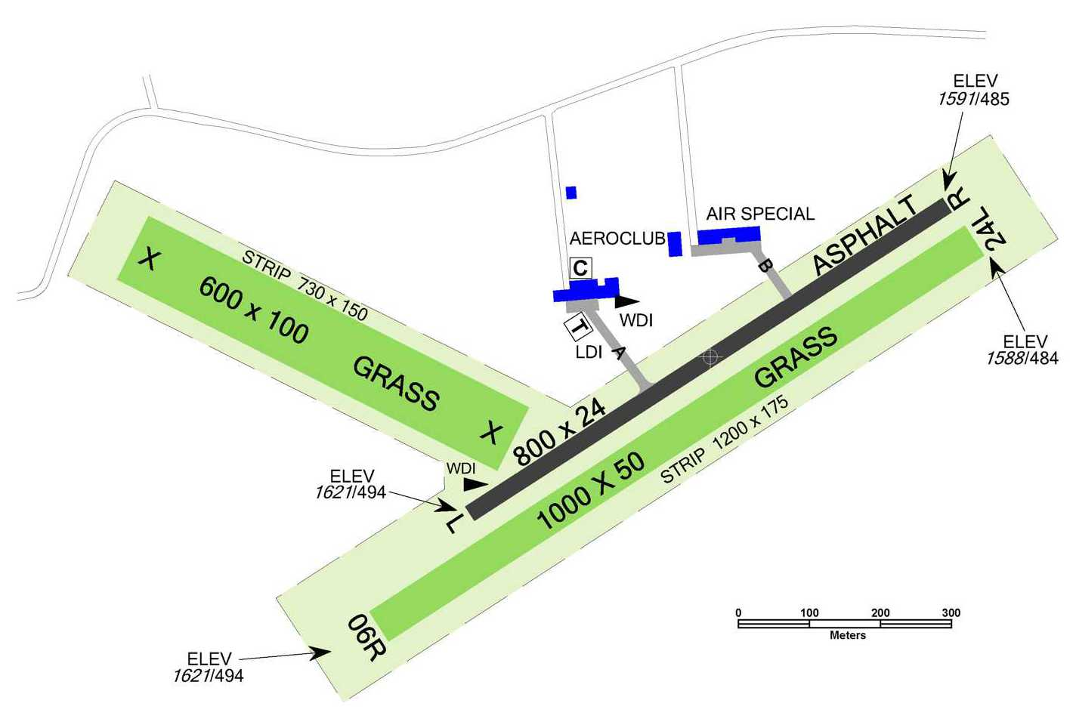
Fig.1: Plan of Hosin Arifield

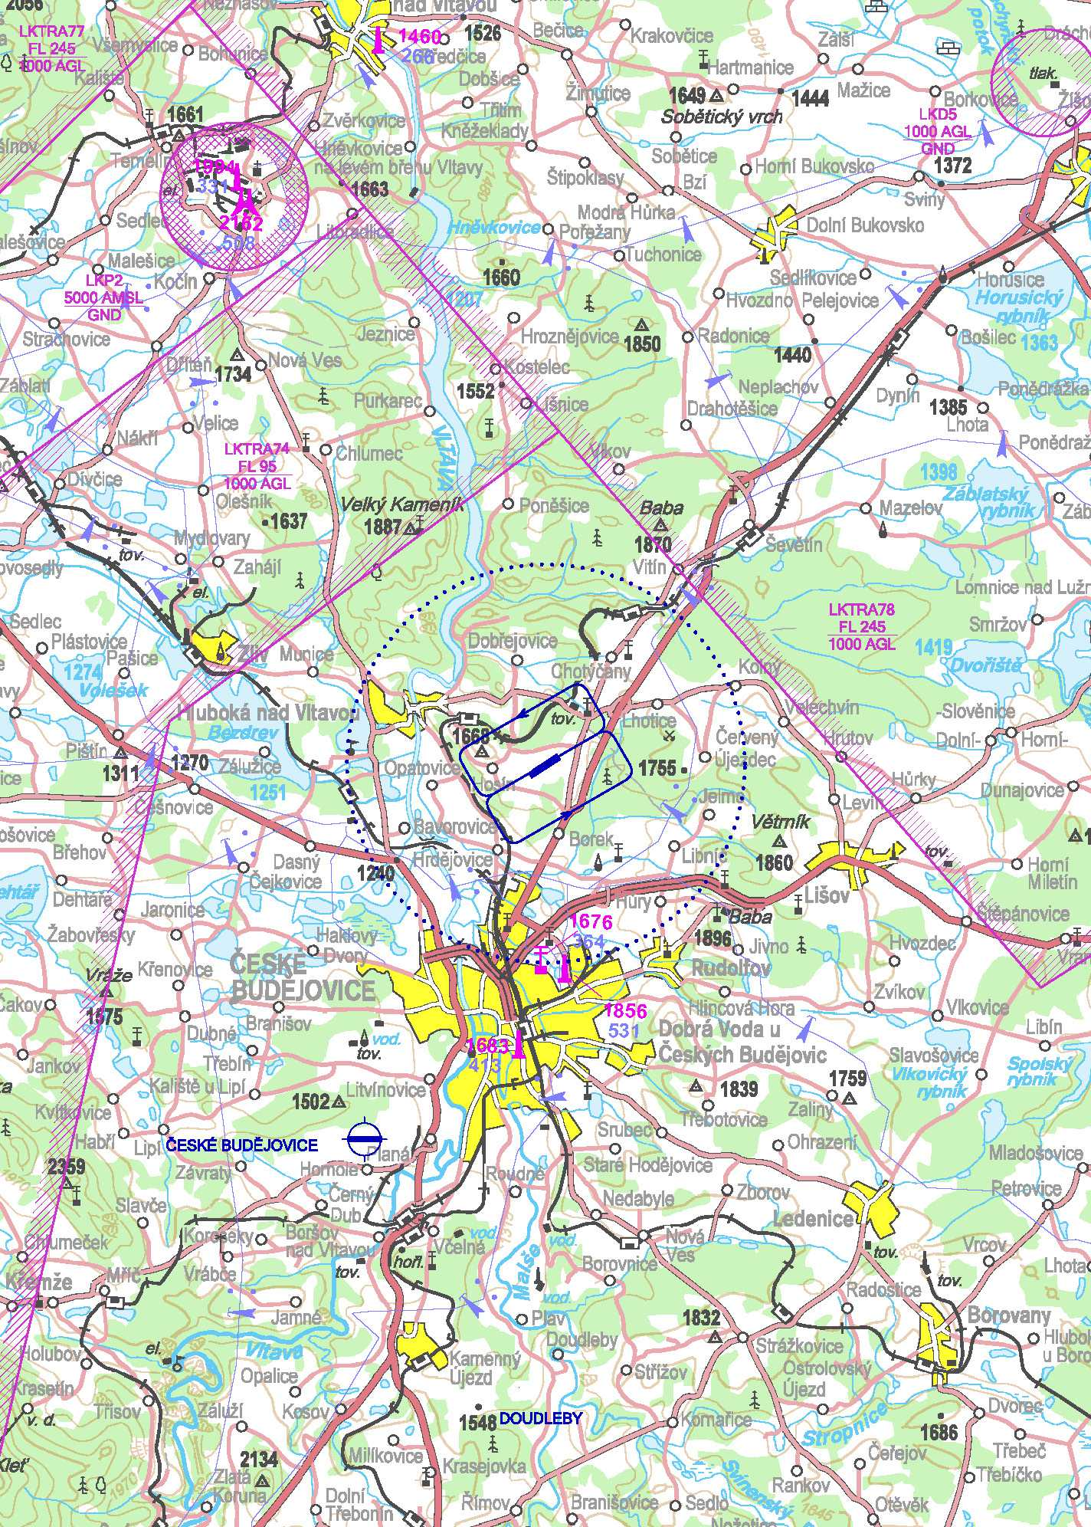
Fig.2: Segment of Aeronatical chart with pattern and situation of vicinity

1st Interntaional Microlight flying navigation camp

- 17rd – 19th July 2022 at Hosin Airfield
- Registration at www.wmc2022.net
- Fees: Free for participants of World Microlight Championship
50 EUR/1 per. for non-registered participants
- Content of camp: - Theory and practise of flying navigation competition
- Preparation of tasks and competition
- Scoring and software for scoring and preparation of map
- More information at www.wmc2022.net

Petr Tucek Navigation Cup 2022

- 16th July 2022 at Hosin Airfield
- One round out of ten Czech open flying navigation cup
- Composed of one Navigation task combined with one Precission landing
- Registration at ppt.laacr.cz, entry fee 150 CZK (about 6 EUR)
- Entry fee content: maps, task description, setting controlling and evaluating the task, lending of GNSS for competition, lunch, free use of the airport

ENTRY FORM EXAMPLE

ENTRY FORM FOR 17th WMC 2022 (23rd – 30th July), Airport Hosin, Czech Republic

Name of National Aero Club

Address

Tel fax

E-mail

We wish to enter the following competitors who qualify under the FAI Nationality or Residence Rules (GS 3.7):

Name | Age | Gender | Comp. class | P1  NAV  ASSTTL | Sporting Licence Nº | Pilot Licence Nº

Note : The maximum number of aircraft which may be entered is ………. with not more than …….. in any class.

Name of Team Leader

Names/number of Assistants if known

Names/number of accompanying technical officials if known

ENTRY FEES
 | Fee | Number | Total Entry fee
Pilot / Nav
Assistant
Team Leader
Technical Official

This amount is enclosed/will be paid by _______ (date) in the form of ______ (currency)

Note : The closing date for the receipt of entry fees is 28 days before the start of the event. Late entries may not be accepted.

We declare that the above information is true.

Signed : Position in NAC

Print Name Date

INSURANCE:
Each competing aircraft shall be covered for public liability risk to the value of _________ (value & currency). Proof of cover must be provided at Registration and before the aircraft is flown. Competitors are strongly advised to take out personal accident cover.

PUBLICITY:
A passport type photograph and a short biographical note for each pilot and the team leader should be provided either with this Entry Form or at latest at Registration.

