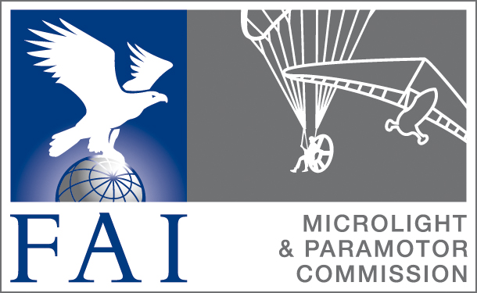
CIMA Plenary 2017

Delegate’s report
NAC: ABUL /CAB

- Introduction

We start to organize paramotor from the end of last year. As a result of this we organize the first National Championship following FAI rules.

2) Sport in your country in 2017
CIMA Championships
FAI CIMA records: ID 18179 and ID 18178
Special achievements or awards
Colibri activity

Brazilian Paramotor Championship 2017:

RPF1T
Champion: Marcio Aita Jr.
2°: Tammy Suhett
3°: Claudio Cardoso

RPL1T
Champion: Cesar Medeiros
2°: Sergio Kawakami (China)
3°: Samuel Rocha

RPL2T
Champion: Anderson Bech (pilot) e Cleber Neckel (copilot)
2° Lugar: Ricardo Maciel (Caju – pilot) e Claudionor Adreolli (Caco – copilot)
3° Lugar: Valcir Ayres (pilot) e Claudinei de Oliveira (Claude – copilot)

RPF2T
Marcelo Simoes Pinto Martins (Matché – pilot) e Sonia Regina de Oliveira (copilot)

Regional championship – State of Paraná 2017
RPF1T
Champion – Alan Braga
2° – Ricardo Maciel
3° – Carlos Hoffmann
RPL1T
Champion – Cesar Medeiros
2° – Valcir Ayres

3) Regulatory and legal issues
Changes to law or regulations
a proposal for regulation of the activities of paramotors, which is expected to enter into vigor in 2018, is being processed by the Brazilian Civil Aviation Authority.

What are the legal MTOW weight limits in your country for:

In Brasil now, we follow the FAA ( USA Authority) rule and they are proposing a change
Microlights: Actual limit is 750Kg but they change the name to Light Aircraft
Autogyros: the limit of MTOW is the same

4) Statistics from
Number of members in your association 450 only paramotor
Number of pilots 1500
Number of aircraft 1500
Total flying hours in 2017 100.000hs
Accident statistics 4

5) Any other comments
Any useful or interesting issues you would like to raise

Recommendations:

a) THE ANN WELCH DIPLOMA
According to the FAI Sporting Code Section 10-2017, page 6, item 2.2.2, I recommend the Ann Welch Diploma to Paratrike Pilot Cesar Medeiros in recognition of his commitment to set a record (ID 18179) and motivate the entire community of the paramotor mainly to overcome its mobility in the condition of being wheelchair.
b) THE COLIBRI DIPLOMA
According to the FAI Sporting Code Section 10 - 2017, page 6, item 2.1.1, I recommend the Colibri Diploma for the Brazilian group formed by:
Ricardo Assumpção Maciel, Samuel Martins da Rocha, Marina Kalousdian, Luiz Carlos Laghi Filho, Luis Rogério Martinati, Sayuri Baez, Victor Carvalho, Sergio Massahito Kawakami, Alan Danilo Martins Braga, Dhiego Rendeiro, Zenilson Rocha, Alexandre Crippa, Fernando Pinho, Olivo Vieceli, Rodolfo H. Junior, Luis Carlos Pinheiro, Roni Purper, Pedro Miguel Gonçalves,
for the excellent work developed in Brazil during the year 2017. They succeeded after a struggle of many years, to make ABUL - Brazilian Ultralight Association again represent the modality of paramotors before CAB - NAC Brazil . The entity that represented the paramotor until October 2016, for almost a decade, was not fulfilling its duties to content. In a year of work through the paramotor board at ABUL, the nominees were able to do, Regional Championships and the Brazilian Paramotor Championship, which allowed the selection of athletes to join the Brazilian team that will participate in WPC2018 in Thailand. It will be the largest Brazilian delegation in the Brazilian history of paramotor, with 17 athletes called, among them 1 wheelchair. All CAB-FAI observer approval work was also developed to make observations of record attempts. This resulted in the registration of the RPL1T closed circuit world record (ID 18179 and 18178). Therefore the nominees are deserving of the Colibri award, for the excellent work performed, putting Brazil again on the world stage.

